Initial error was encountered.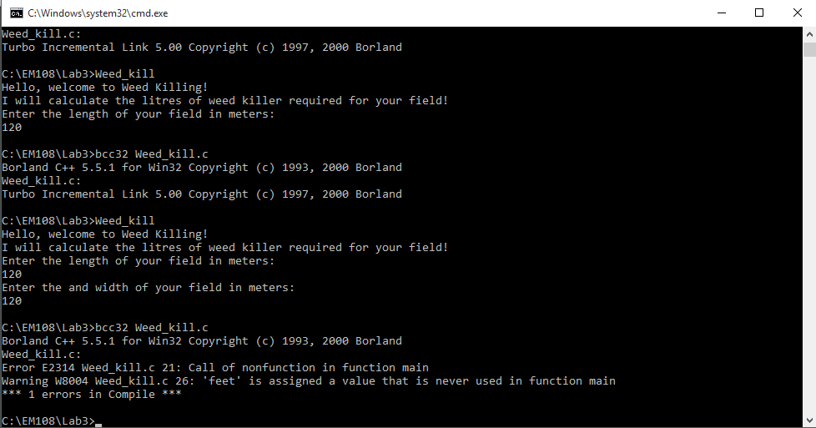

 missing * between weed killer and (

There was an error in grammar, a missing : in the second last line.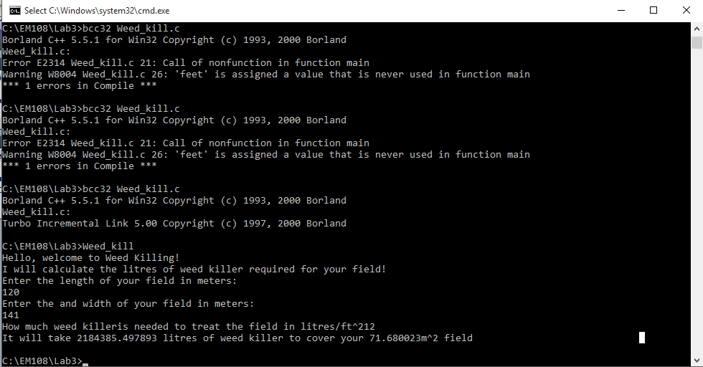

Issue was corrected and programme deemed correctly working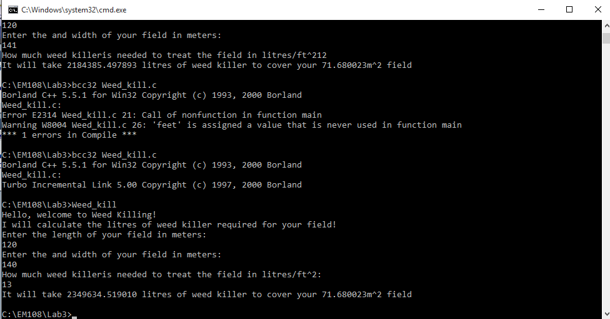

A closing message was then added.

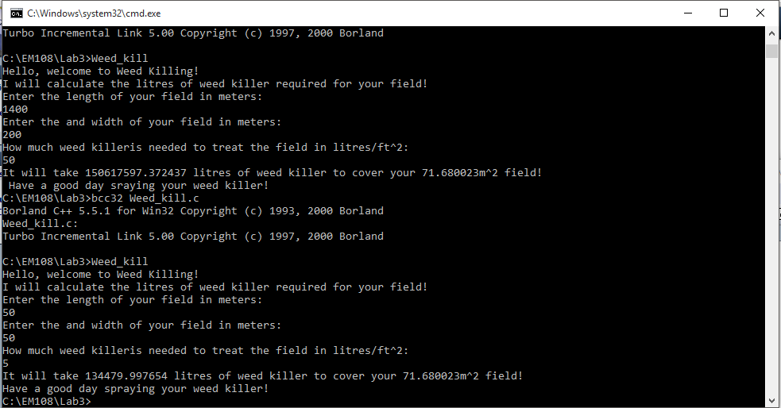

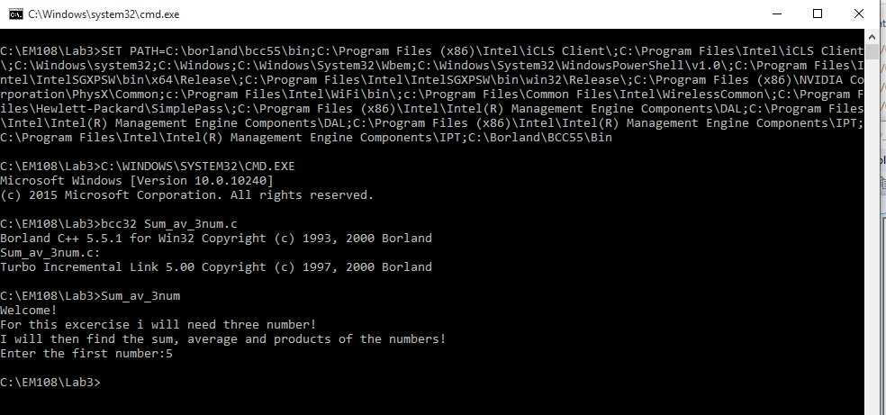The programme crashed due to the lack of & symbol in scan function

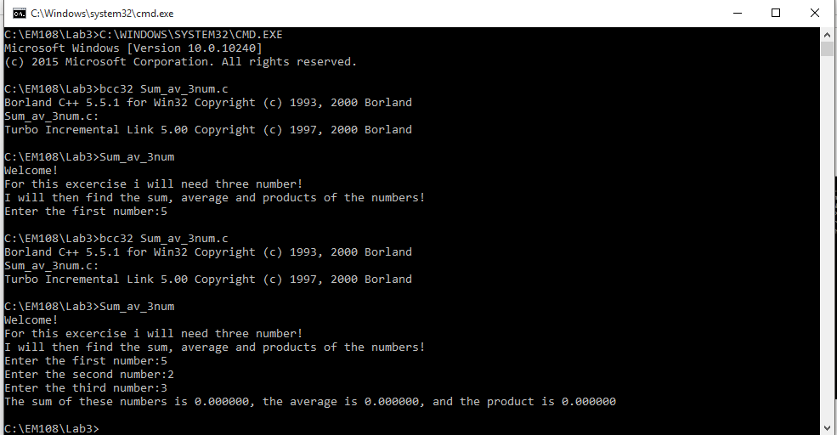Numbers all printed as 0 due to error in the code

Code Correctly Working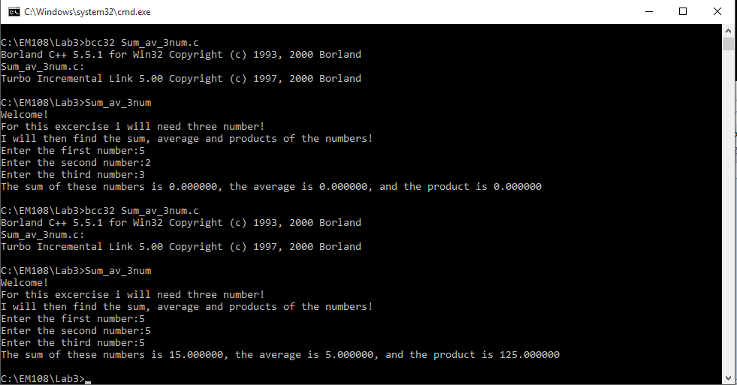

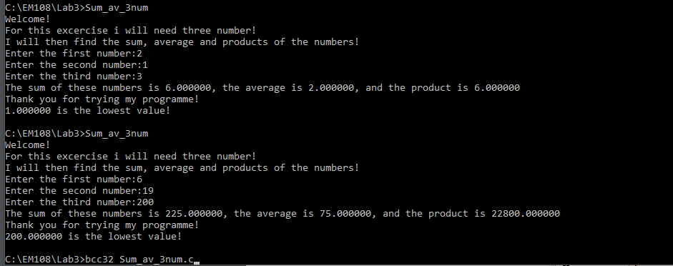

if(num_1>num_2)

if(num_2<num_3)

printf("%f is the lowest value!\n", num_2);

else

printf("%f is the lowest value!\n", num_3);

else

printf("%f is the lowest value!\n", num_1);corrected code

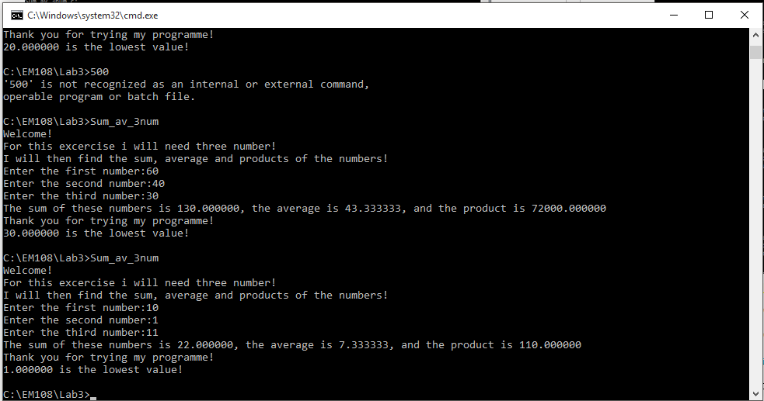

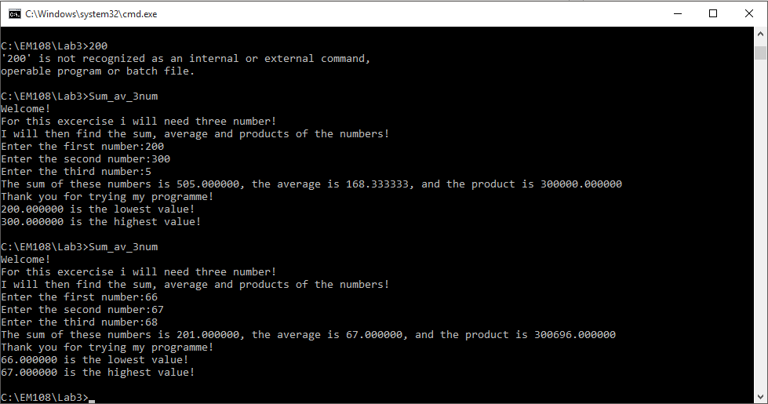

Highest number not working correctly

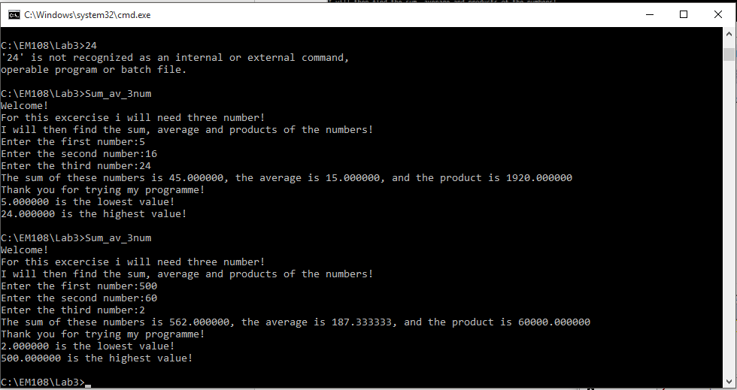

Programme fully working.

if(num_1<num_2)

if(num_2>num_3)

printf("%f is the highest value!\n", num_2);

else

printf("%f is the highest value!\n", num_3);

else

printf("%f is the highest value!\n", num_1);

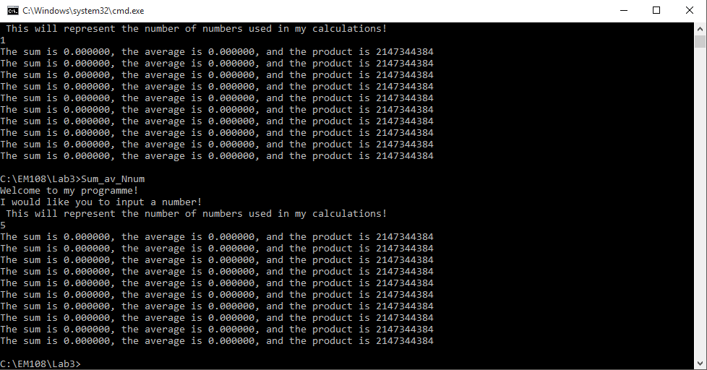

Code runs but with incorrect outputs.

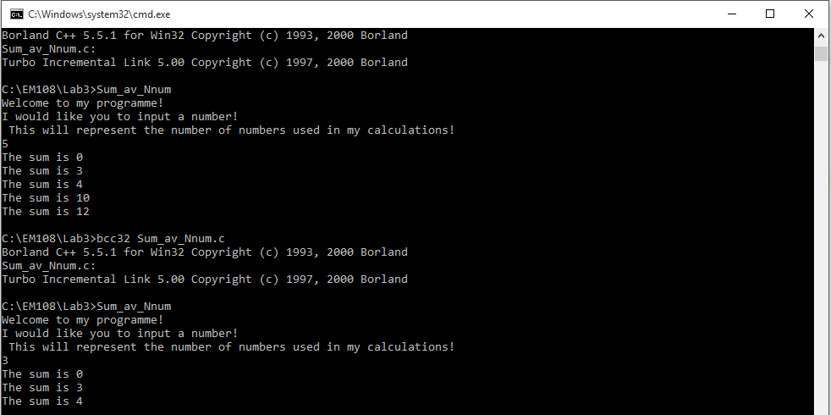

Code changed. Programme again runs but with incorrect outputs.

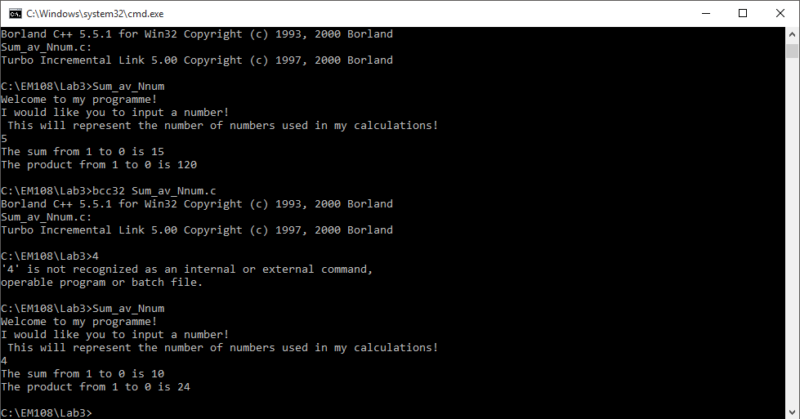

While loop introduced which corrected any errors.

while(num != 0){

sum = sum + num;

product = product * num;

num--;

}

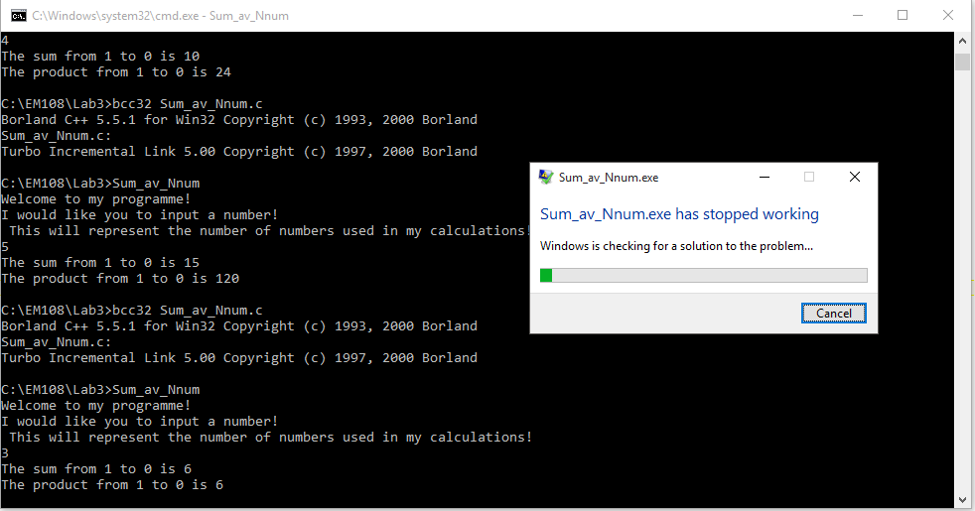

Error in code for average caused the programme to crash.

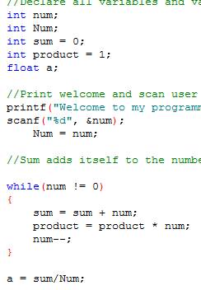Error in code found. Num and a variables declared. Num was set to = num after the scan. After the while loop, the average variable, a was set and defined

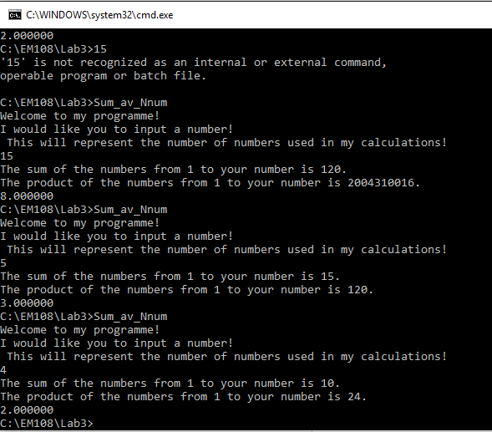Code correctly working.

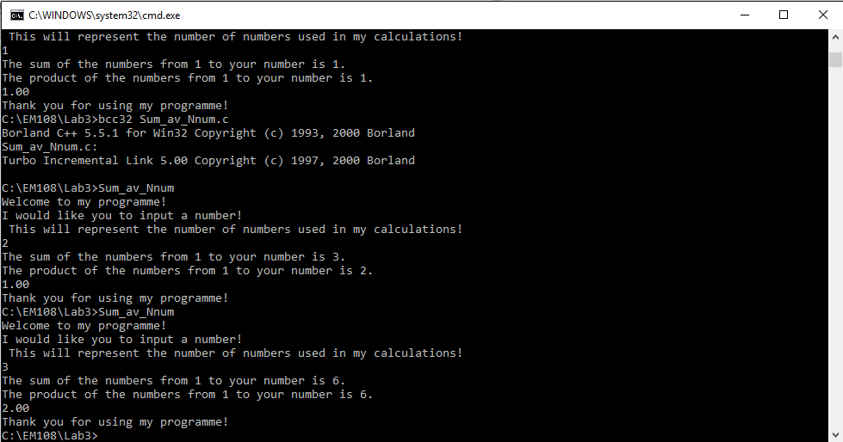

Number of decimal points added and closing message added.